NATIONAL TECHNICAL UNIVERSITY OF ATHENS
Erasmus Code: G ATHINE02
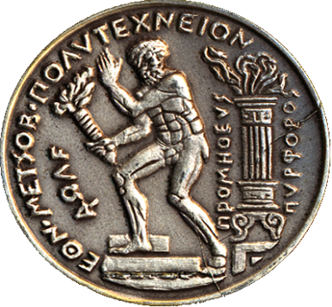 | “Prometheus the Torchbearer”  Choosing "Prometheus bringing the fire from the gods to the mankind", as its symbol, NTUA never loses sight of the real human needs and dimensions. Its final concerns are quality of life and protection of democratic rights and achievements. It integrates its mission by adopting the timeless valuable social role of the traditional Universities.
https://www.ntua.gr/en/
PATISSION COMPLEX  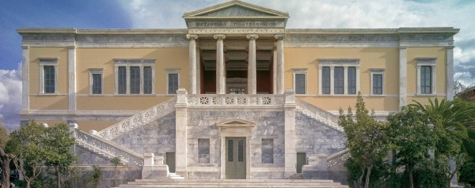  Architecture  PATISSION COMPLEX  42, PATISSIONSTR  10682 ATHENS  GREECE  https://www.google.com/maps/place/National+Metsovio+Polythechnic,+Athina+106+82,+Greece/@37.98784,23.731804,1369m/data=!3m1!1e3!4m5!3m4!1s0x14a1bd3161d1cae7:0xcf7f3f434657d025!8m2!3d37.9877159!4d23.7318586?hl=en-US | ZOGRAFOU CAMPUS  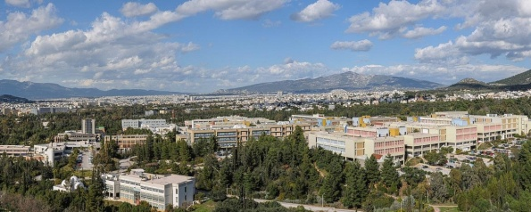  Civil, Mechanical, Electrical, Chemical, Rural, Mining, Naval, Applied Mathematics & Physics  European Educational Programmes Office  9, HEROON POLYTECHNEIOU STR  157 72 ATHENS  GREECE  http://map.ntua.gr/google_en.htm

EUROPEAN EDUCATIONAL PROGRAMMES OFFICE
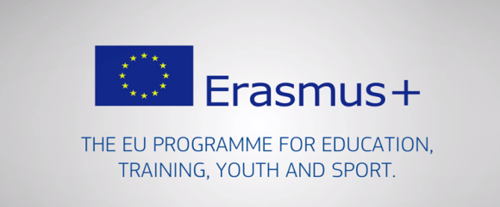
http://erasmus.ntua.gr/en
Οffice Manager | Aristea KAPETANAKI | (+)30 210 772 1017  @iroffice@central.ntua.gr | Please contact:  iroffice@central.ntua.gr
Financial Support  Staff Mobility  Interinstitutional Agreements - KA 131 | Vassiliki THOMA | (+)30 210 772 1199  @vthoma@central.ntua.gr | Please contact:  vthoma@centra.ntua.gr
Erasmus+ Officer  School of Architecture | Eleftheria VAROUCHAKI | (+)30 210 772 3834  evarouchaki@arch.ntua.gr | Please contact:  evarouchaki@arch.ntua.gr
International Credit Mobility – KA 171  Interinstitutional Agreements - KA 131 | Eleftheria  SKORDALAKI | (+)30 210 772 4172  @eeskorda@mail.ntua.gr | Please contact:  eeskorda@mail.ntua.gr
Outgoing Students for Studies – KA 131 | Spyros PITSIKALIS | (+)30 210 772 4056  ntuaerasmus@gmail.com | Please contact:  ntuaerasmus@gmail.com
Outgoing Students for Traineeship | Konstantina BAKOU | (+)30 210 772 4052  praktikierasmusntua@gmail.com | Please contact:  praktikierasmusntua@gmail.com
Incoming Students – KA 131 | Konstantina BAKOU | (+)30 210 772 4052  @ kbakou@mail.ntua.gr | Please contact:  @ kbakou@mail.ntua.gr
NATIONAL TECHNICAL UNIVERSITY OF ATHENS, ZOGRAFOU CAMPUS
ADMINISTRATION BUILDING - DIRECTORATE OF STUDIES
EUROPEAN EDUCATIONAL PROGRAMMES OFFICE - ROOM 106 -1st Floor
9, HEROON POLYTECHNEIOU STR, 157 72 ATHENS, GREECE

SCHOOL OF CIVIL ENGINEERING
Erasmus+ Subject Area Code: 0732
(https://www.civil.ntua.gr/erasmus/
Erasmus+ Departmental Coordinator |  | Prof. E. SAPOUNTZAKIS |  | (+)30 210 772 1620, 1718  @cvsapoun@central.ntua.gr
Secretary | Christos ANTARAS |  | (+)30 210 772 3419  @chrisna@civil.ntua.gr |  | Please contact:  chrisna@civil.ntua.gr

SCHOOL OF MECHANICAL ENGINEERING
Erasmus+ Subject Area Code: 0715
http://www.mech.ntua.gr/en/international-courses
Ects: http://www.mech.ntua.gr/en/course-program-1
Curriculum: http://www.mech.ntua.gr/files/studyguide/ME-guide-en.pdf
Erasmus+ Departmental Coordinator |  | Assoc. Prof. A. MARKOPOULOS |  | (+)30 210 772 4299  @amark@mail.ntua.gr
Secretary | Panagiota KYRIAZI |  | (+)30 210 772 3535  @  panagiota_kyriazi@mail.ntua.gr |  | Please contact:  panagiota_kyriazi@mail.ntua.gr

SCHOOL OF ELECTRICAL & COMPUTER ENGINEERING
Erasmus+ Subject Area Code: 0714
https://www.ece.ntua.gr/en/undergraduate/courses
https://www.ece.ntua.gr/media/630/Undergraduate_Curriculum_SchoolofECE_NTUA_2020_2021-20210220.pdf
https://www.ece.ntua.gr/en/postgraduate
Erasmus+ Departmental Coordinator |  | Prof. F. TOPALIS |  | (+)30 210 772 3627  @ fvt@mail.ntua.gr
Secretary | Eleni DIONYSOPOULOU |  | (+)30 210 772 4309  @ secreta@ece.ntua.gr |  | Please contact:  secreta@ece.ntua.gr

SCHOOL OF ARCHITECTURE
Erasmus+ Subject Area Code: 0731
Course description - Ects
Please contact: evarouchaki@arch.ntua.gr

Erasmus+ Departmental Coordinator |  | Prof. H. HANIOTOU |  | (+)30 210 772 3822  @ hhaniotou@arch.ntua.gr
Incoming Student  Administrative Coordinator | Eleftheria VAROUCHAKI |  | (+)30 210 772 3834  @  evarouchaki@arch.ntua.gr |  | Please contact:  evarouchaki@arch.ntua.gr

SCHOOL OF CHEMICAL ENGINEERING
Erasmus+ Subject Area Code: 0711
Course Description
Undergraduate Courses: https://www.chemeng.ntua.gr/the_semester
Course Guide 2022-2023: https://www.chemeng.ntua.gr/tools/getfile.php?file=3330
International Academic Cooperation Programs/ pdf Available Courses: https://www.chemeng.ntua.gr/tools/getfile.php?file=2468

Erasmus+ Departmental Coordinator |  | Prof. K. KORDATOS |  | (+)30 210 772 3100  @kordatos@central.ntua.gr
Secretary | Sofia ANDRI |  | (+)30 210 772 3059  @ andris@chemeng.ntua.gr |  | Please contact:  andris@chemeng.ntua.gr

SCHOOL OF RURAL, SURVEYING AND GEOINFORMATICS ENGINEERING
Erasmus+ Subject Area Code: 0532
https://www.survey.ntua.gr/files/Academic_calendar/Curriculum_Guide/SRSE__HANDBOOK_2020-20021_FINAL.pdf

Erasmus+ Departmental Coordinator |  | Prof. M. KAVOURAS |  | (+)30 210 772 2731  @ mkav@mail.ntua.gr
Secretary | Efi SIDIROPOULOU |  | (+)30 210 772 4218  @secret@survey.ntua.gr |  | Please contact:  secret@survey.ntua.gr

SCHOOL OF MINING & METALLURGICAL ENGINEERING
Erasmus+ Subject Area Code: 0724
Course List
http://eng.metal.ntua.gr/?page_id=3743
ECTS Allocation
http://eng.metal.ntua.gr/wp-content/uploads/2023/11/ects_erasmus_english_final_2023.pdf

Erasmus+ Departmental Coordinator |  | Prof. G. FOURLARIS |  | (+)30 210 772 2481, 2171  @ mmgf@mail.ntua.gr
Secretary | Elena ELEFTHERIOU |  | (+)30 210 772 2067  @secretary@metal.ntua.gr |  | Please contact:  secretary@metal.ntua.gr

SCHOOL OF NAVAL ARCHITECTURE & MARINE ENGINEERING
Erasmus+ Subject Area Code: 0716
https://drive.google.com/file/d/1-GXoz3Qdh8sRd1KZqgU1QufdMZfhicpv/view

Erasmus+ Departmental Coordinator |  | Prof. G. GEORGIOU |  | (+)30 210 772 2716, 1117  @ georgiou.yannis@gmail.com
Secretary | Petty GIANNAKA |  | (+)30 210 772 2196  @secretariat@naval.ntua.gr |  | Please contact:  secretariat@naval.ntua.gr

SCHOOL OF APPLIED MATHEMATICAL & PHYSICAL SCIENCES
Erasmus+ Subject Area Codes: 0533 / Physics, 0541 / Mathematics
http://semfe.ntua.gr/en/erasmus

Erasmus+ Departmental Coordinator |  | Prof. N. MAVROMATOS |  | (+)30 210 772 1747  @ mavroman@mail.ntua.gr
Secretary | Μaria ANGELOPOULOU |  | (+)30 210 772 4276 |  | Please contact:  erasmus_semfe@mail.ntua.gr
Secretary | Avra KATZILIERI |  | (+)30 210 772 4190

