NATIONAL TECHNICAL UNIVERSITY OF ATHENS
Erasmus Code: G ATHINE02
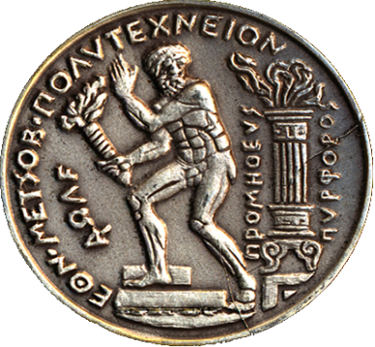 | “Prometheus the Torchbearer”  Choosing "Prometheus bringing the fire from the gods to the mankind", as its symbol, NTUA never loses sight of the real human needs and dimensions. Its final concerns are quality of life and protection of democratic rights and achievements. It integrates its mission by adopting the timeless valuable social role of the traditional Universities.
https://www.ntua.gr/en/
PATISSION COMPLEX  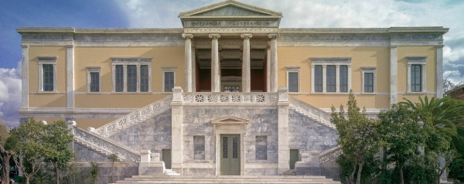  Architecture  PATISSION COMPLEX  42, PATISSIONSTR  10682 ATHENS  GREECE  https://www.google.com/maps/place/National+Metsovio+Polythechnic,+Athina+106+82,+Greece/@37.98784,23.731804,1369m/data=!3m1!1e3!4m5!3m4!1s0x14a1bd3161d1cae7:0xcf7f3f434657d025!8m2!3d37.9877159!4d23.7318586?hl=en-US | ZOGRAFOU CAMPUS  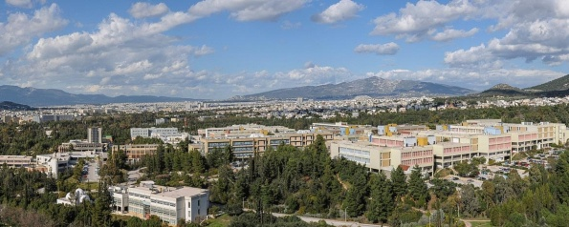  Civil, Mechanical, Electrical, Chemical, Rural, Mining, Naval, Applied Mathematics & Physics  European Educational Programmes Office  9, HEROON POLYTECHNEIOU STR  157 72 ATHENS  GREECE  http://map.ntua.gr/google_en.htm

EUROPEAN EDUCATIONAL PROGRAMMES OFFICE
http://erasmus.ntua.gr/en
Οffice Manager | Aristea KAPETANAKI | (+)30 210 772 1017  @iroffice@central.ntua.gr | Please contact:  iroffice@central.ntua.gr
Financial Support  Staff Mobility  Interinstitutional Agreements - KA 131 | Vassiliki THOMA | (+)30 210 772 1199  @vthoma@central.ntua.gr | Please contact:  vthoma@centra.ntua.gr
Erasmus+ Officer  School of Architecture | Eleftheria VAROUCHAKI | (+)30 210 772 3834  evarouchaki@arch.ntua.gr | Please contact:  evarouchaki@arch.ntua.gr
International Credit Mobility – KA 171  Interinstitutional Agreements - KA 131 | Eleftheria  SKORDALAKI | (+)30 210 772 4172  @eeskorda@mail.ntua.gr | Please contact:
Outgoing Students for Studies | Spyros PITSIKALIS | (+)30 210 772 4056  ntuaerasmus@gmail.com | Please contact:  ntuaerasmus@gmail.com
Outgoing Students for Traineeship | Konstantina BAKOU | (+)30 210 772 4052  praktikierasmusntua@gmail.com | Please contact:  praktikierasmusntua@gmail.com
Incoming Students | Konstantina BAKOU | (+)30 210 772 4052  @ kbakou@mail.ntua.gr | Please contact:  @ kbakou@mail.ntua.gr
NATIONAL TECHNICAL UNIVERSITY OF ATHENS, ZOGRAFOU CAMPUS
ADMINISTRATION BUILDING - DIRECTORATE OF STUDIES
EUROPEAN EDUCATIONAL PROGRAMMES OFFICE - ROOM 106 -1st Floor
9, HEROON POLYTECHNEIOU STR, 157 72 ATHENS, GREECE

SCHOOL OF CIVIL ENGINEERING
Erasmus+ Subject Area Code: 0732
Course description - Ects
http://www.civil.ntua.gr/info/Erasmus/
Erasmus+ Departmental Coordinator |  | Prof. E.SAPOUNTZAKIS |  | (+)30 210 772 1718  @cvsapoun@central.ntua.gr
Secretary | Christos ANTARAS |  | (+)30 210 772 3419  @chrisna@civil.ntua.gr |  | Monday to Friday  10:30 – 13:30

SCHOOL OF MECHANICAL ENGINEERING
Erasmus+ Subject Area Code: 0715
http://www.mech.ntua.gr/en/international-courses
http://www.mech.ntua.gr/en/education/erasmus
http://www.mech.ntua.gr/en/education/ugrads
http://www.mech.ntua.gr/files/studyguide/ME_EN-2013-2014.pdf
Erasmus+ Departmental Coordinator |  | Assoc. Prof. A. Markopoulos |  | (+)30 210 772 4299  @amark@mail.ntua.gr
Secretary | Panagiota KYRIAZI |  | (+)30 210 772 3535  @ panagiota_kyriazi@mail.ntua.gr |  | Mon, Wed, Fri  11:30 – 13:30

SCHOOL OF ELECTRICAL & COMPUTER ENGINEERING
Erasmus+ Subject Area Code: 0714
https://www.ece.ntua.gr/en
https://www.ece.ntua.gr/en/undergraduate/info
Course description - ECTS
https://www.ece.ntua.gr/media/630/Undergraduate_Curriculum_SchoolofECE_NTUA_2020_2021-20210220.pdf
Erasmus+ Departmental Coordinator |  | Prof. F. TOPALIS |  | (+)30 210 772 3627  @fvt@central.ntua.gr  @topalis@cs.ntua.gr
Secretary | Eleni DIONYSOPOULOU |  | (+)30 210 772 4309  @secreta@ece.ntua.gr |  | Mon – Wed – Fri  11:00 – 13:00

SCHOOL OF ARCHITECTURE
Erasmus+ Subject Area Code: 0731
Course description + Ects
Please contact: evarouchaki@arch.ntua.gr

Erasmus+ Departmental Coordinator |  | Prof. H. HANIOTOU |  | (+)30 210 772 3822  @ hhaniotou@arch.ntua.gr
Incoming Student  Administrative Coordinator | Eleftheria VAROUCHAKI |  | @  evarouchaki@arch.ntua.gr |  | Please contact:  evarouchaki@arch.ntua.gr

SCHOOL OF CHEMICAL ENGINEERING
Erasmus+ Subject Area Code: 0711
Course Description
http://www.chemeng.ntua.gr/the_semester/_en
Courses Guide 2020-2021 in English
Ects
Course Guide 2015-2016 (English)
Erasmus+ Departmental Coordinator |  | Prof. K. KORDATOS |  | (+)30 210 772 3100  @kordatos@central.ntua.gr
Secretary | Alexandros PAPADIMITRIOU |  | (+)30 210 772 1134  @apapa@mail.ntua.grr |  | Monday to Friday  11:30 – 13:30

SCHOOL OF RURAL, SURVEYING AND GEOINFORMATICS ENGINEERING
Erasmus+ Subject Area Code: 0532
Course Description
http://www.survey.ntua.gr/files/secr_announcements/proptyxiakes/odigos-spoudwn-akad-imer/Curriculum-Guide-srse-en-2009-2010.pdf
ECTS
http://www.survey.ntua.gr/el/announcements/erasmus/571-pistot-monad-ana-mathima

Erasmus+ Departmental Coordinator |  | Prof. M. KAVOURAS |  | (+)30 210 772 2731  @ mkav@mail.ntua.gr
Secretary | Efi SIDIROPOULOU |  | (+)30 210 772 4218  @secret@survey.ntua.gr |  | Monday to Friday  11:30 – 13:30

SCHOOL OF MINING & METALLURGICAL ENGINEERING
Erasmus+ Subject Area Code: 0724
Course Description
http://old-2017.metal.ntua.gr/index.pl/erasmus_plus_en
ECTS
http://old-2017.metal.ntua.gr/uploads/4986/ECTS_School_of_Mining_and_Metallurgical_Engineering.pdf

Erasmus+ Departmental Coordinator |  | Prof. G. FOURLARIS |  | (+)30 210 772 2481, 2171  @ mmgf@mail.ntua.gr
Secretary | Elena ELEFTHERIOU |  | (+)30 210 772 2067  @secretary@metal.ntua.gr |  | Monday to Friday  11:00 – 13:30

SCHOOL OF NAVAL ARCHITECTURE & MARINE ENGINEERING
Erasmus+ Subject Area Code: 0716
Course Description + Ects
https://drive.google.com/file/d/1_aq-gkxJ7T_hjDlhOihndF1059KwOa8v/view

Erasmus+ Departmental Coordinator |  | Prof. G. GEORGIOU |  | (+)30 210 772 2716, 1117  @ georgiou.yannis@gmail.com  @ georgiou@central.ntua.gr
Secretary | Petty GIANNAKA |  | (+)30 210 772 2196  @secretariat@naval.ntua.gr |  | Monday to Friday  10:00 – 14:00

SCHOOL OF APPLIED MATHEMATICAL & PHYSICAL SCIENCES
Erasmus+ Subject Area Codes: 0533 / Physics - 0541 / Mathematics
Course Description + Ects
http://semfe.ntua.gr/en/latest-news/information-for-incoming-erasmus-students
Erasmus+ Departmental Coordinator |  | Prof. N. MAVROMATOS |  | (+)30 210 772 1747  @ mavroman@mail.ntua.gr
Secretary | Μaria ANGELOPOULOU  (+)30 210 772 4276  erasmus_semfe@mail.ntua.gr |  | Avra KATZILIERI  (+)30 210 772 4190 erasmus_semfe@mail.ntua.gr |  | Monday to Friday  11:00 – 13:00

