NATIONAL TECHNICAL UNIVERSITY OF ATHENS
Erasmus Code: G ATHINE02
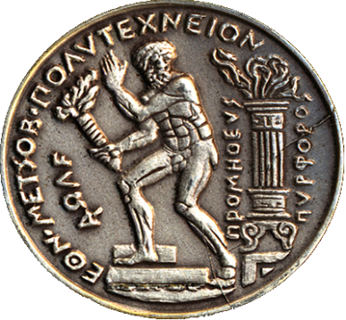 | “Prometheus the Torchbearer”  Choosing "Prometheus bringing the fire from the gods to the mankind", as its symbol, NTUA never loses sight of the real human needs and dimensions. Its final concerns are quality of life and protection of democratic rights and achievements. It integrates its mission by adopting the timeless valuable social role of the traditional Universities.
https://www.ntua.gr/en/
PATISSION COMPLEX  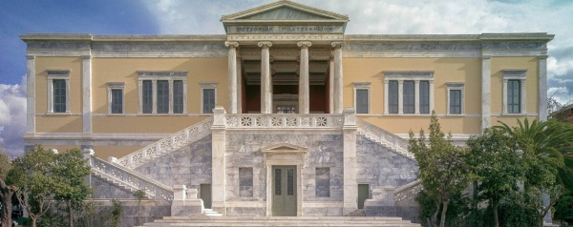  Architecture  PATISSION COMPLEX  42, PATISSIONSTR  10682 ATHENS  GREECE  https://www.google.com/maps/place/National+Metsovio+Polythechnic,+Athina+106+82,+Greece/@37.98784,23.731804,1369m/data=!3m1!1e3!4m5!3m4!1s0x14a1bd3161d1cae7:0xcf7f3f434657d025!8m2!3d37.9877159!4d23.7318586?hl=en-US | ZOGRAFOU CAMPUS  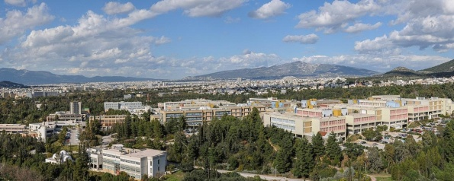  Civil, Mechanical, Electrical, Chemical, Rural, Mining, Naval, Applied Mathematics & Physics  European Educational Programmes Office  9, HEROON POLYTECHNEIOU STR  157 80 ATHENS  GREECE  http://map.ntua.gr/google_en.htm

EUROPEAN EDUCATIONAL PROGRAMMES OFFICE
http://erasmus.ntua.gr/en
Head | AristeaKAPETANAKI | (+)30 210 772 1017  @iroffice@central.ntua.gr | Please contact:  iroffice@central.ntua.gr
Incoming Student Coordinator | EleftheriaSKORDALAKI | (+)30 210 772 4172  @eeskorda@mail.ntua.gr | Please contact:  eeskorda@mail.ntua.gr
NATIONAL TECHNICAL UNIVERSITY OF ATHENS, ZOGRAFOU CAMPUS
ADMINISTRATION BUILDING - DEPARTMENT OF STUDIES
EUROPEAN EDUCATIONAL PROGRAMMES OFFICE - ROOM 106 -1st Floor
9, HEROON POLYTECHNEIOU STR, 157 80 ATHENS, GREECE

SCHOOL OF CIVIL ENGINEERING
Erasmus+ Subject Area Code:0732
Course description
http://www.civil.ntua.gr/courses/
Ectshttps://docs.google.com/spreadsheets/d/1MxsJqrmYeGndideMVsUeLRBCUM6gBqQEB5S51LSuSMM/edit#gid=1983121083
Erasmus+ Departmental Coordinator |  | Prof. E.SAPOUNTZAKIS |  | (+)30 210 772 1620, 1718  @cvsapoun@central.ntua.gr
Secretary | Christos ANTARAS |  | (+)30 210 772 3419  @chrisna@civil.ntua.gr |  | Please contact:  chrisna@civil.ntua.gr

SCHOOL OF MECHANICAL ENGINEERING
Erasmus+ Subject Area Code:0715
http://www.mech.ntua.gr/en/international-courses
http://www.mech.ntua.gr/en/education/erasmus
http://www.mech.ntua.gr/en/education/ugrads
http://www.mech.ntua.gr/files/studyguide/ME_EN-2013-2014.pdf
Erasmus+ Departmental Coordinator |  | Prof. S. KARELLAS |  | (+)30 210 772 2810  @sotokar@mail.ntua.gr
Secretary | Dimitra POULLA |  | (+)30 210 772 3578  @ phdmecheng@mail.ntua.gr |  | Please contact:  phdmecheng@mail.ntua.gr

SCHOOL OF ELECTRICAL & COMPUTER ENGINEERING
Erasmus+ Subject Area Code: 0714
https://www.ece.ntua.gr/en
https://www.ece.ntua.gr/en/undergraduate/info
Course description - ECTS
https://www.ece.ntua.gr/media/630/Undergraduate_Curriculum_SchoolofECE_NTUA_2020_2021-20210220.pdf
Erasmus+ Departmental Coordinator |  | Prof. F. TOPALIS |  | (+)30 210 772 3627  @fvt@central.ntua.gr  @topalis@cs.ntua.gr
Secretary | Aimilia KOUGΚOULOU |  | (+)30 210 772 1889  @secreta@ece.ntua.gr |  | Please contact:  secreta@ece.ntua.gr

SCHOOL OF ARCHITECTURE
Erasmus+ Subject Area Code:0731
Course description + Ects
Please contact: evarouchaki@arch.ntua.gr

Erasmus+ Departmental Coordinator |  | Prof. P. TOURNIKIOTIS |  | (+)30 210 772 3324  @ tourni@central.ntua.gr
Incoming Student  Administrative Coordinator | EleftheriaVAROUCHAKI |  | @  evarouchaki@arch.ntua.gr |  | Please contact:evarouchaki@arch.ntua.gr

SCHOOL OF CHEMICAL ENGINEERING
Erasmus+ Subject Area Code:0711
Course Description
http://www.chemeng.ntua.gr/the_semester
Erasmus+ Departmental Coordinator |  | Prof. E. GRIGOROPOULOU  (+)30 210 772 3222  @lenag@chemeng.ntua.gr |  | Prof. K. KORDATOS  (+)30 210 772 3100  @kordatos@central.ntua.gr
Secretary | Antonia LABROPOULOU |  | (+)30 210 772 1433  @labrop@mail.ntua.gr |  | Please contact:  labrop@mail.ntua.gr

SCHOOL OF RURAL, SURVEYING AND GEOINFORMATICS ENGINEERING
Erasmus+ Subject Area Code:0532
Course Description
http://www.survey.ntua.gr/files/secr_announcements/proptyxiakes/odigos-spoudwn-akad-imer/Curriculum-Guide-srse-en-2009-2010.pdf
ECTS
http://www.survey.ntua.gr/el/announcements/erasmus/571-pistot-monad-ana-mathima

Erasmus+ Departmental Coordinator |  | Prof. A. GEORGOPOULOS |  | (+)30 210 772 2675  @ drag@central.ntua.gr
Secretary | EfiSIDIROPOULOU |  | (+)30 210 772 4218  @secret@survey.ntua.gr |  | Please contact:  secret@survey.ntua.gr

SCHOOL OF MINING & METALLURGICAL ENGINEERING
Erasmus+ Subject Area Code:0724
Course Description
http://old-2017.metal.ntua.gr/index.pl/erasmus_plus_en
ECTS
http://old-2017.metal.ntua.gr/uploads/4986/ECTS_School_of_Mining_and_Metallurgical_Engineering.pdf

Erasmus+ Departmental Coordinator |  | Prof. G. FOURLARIS |  | (+)30 210 772 2481, 2171  @ mmgf@mail.ntua.gr
Secretary | ElenaELEFTHERIOU |  | (+)30 210 772 2067  @secretary@metal.ntua.gr |  | Please contact:  secretary@metal.ntua.gr

SCHOOL OF NAVAL ARCHITECTURE & MARINE ENGINEERING
Erasmus+ Subject Area Code:0716
Course Description + Ects
https://drive.google.com/file/d/1_aq-gkxJ7T_hjDlhOihndF1059KwOa8v/view

Erasmus+ Departmental Coordinator |  | Prof. G. GEORGIOU |  | (+)30 210 772 2716, 1117  @ georgiou.yannis@gmail.com  @ georgiou@central.ntua.gr
Secretary | PettyGIANNAKA |  | (+)30 210 772 2196  @secretariat@naval.ntua.gr |  | Please contact:  secretariat@naval.ntua.gr

SCHOOL OF APPLIED MATHEMATICAL & PHYSICAL SCIENCES
Erasmus+ Subject Area Codes:0533 / Physics 0541 / Mathematics
Course Description + Ects
http://semfe.ntua.gr/en/latest-news/information-for-incoming-erasmus-students
Erasmus+ Departmental Coordinator |  | Prof. L. Tsetseris |  | (+)30 210 772 3046  @ leont@mail.ntua.gr
Secretary | ΜariaANGELOPOULOU |  | (+)30 210 772 4276  @semfe@central.ntua.gr |  | Please contact:  semfe@central.ntua.gr

